**MOUSAMI PATRA**

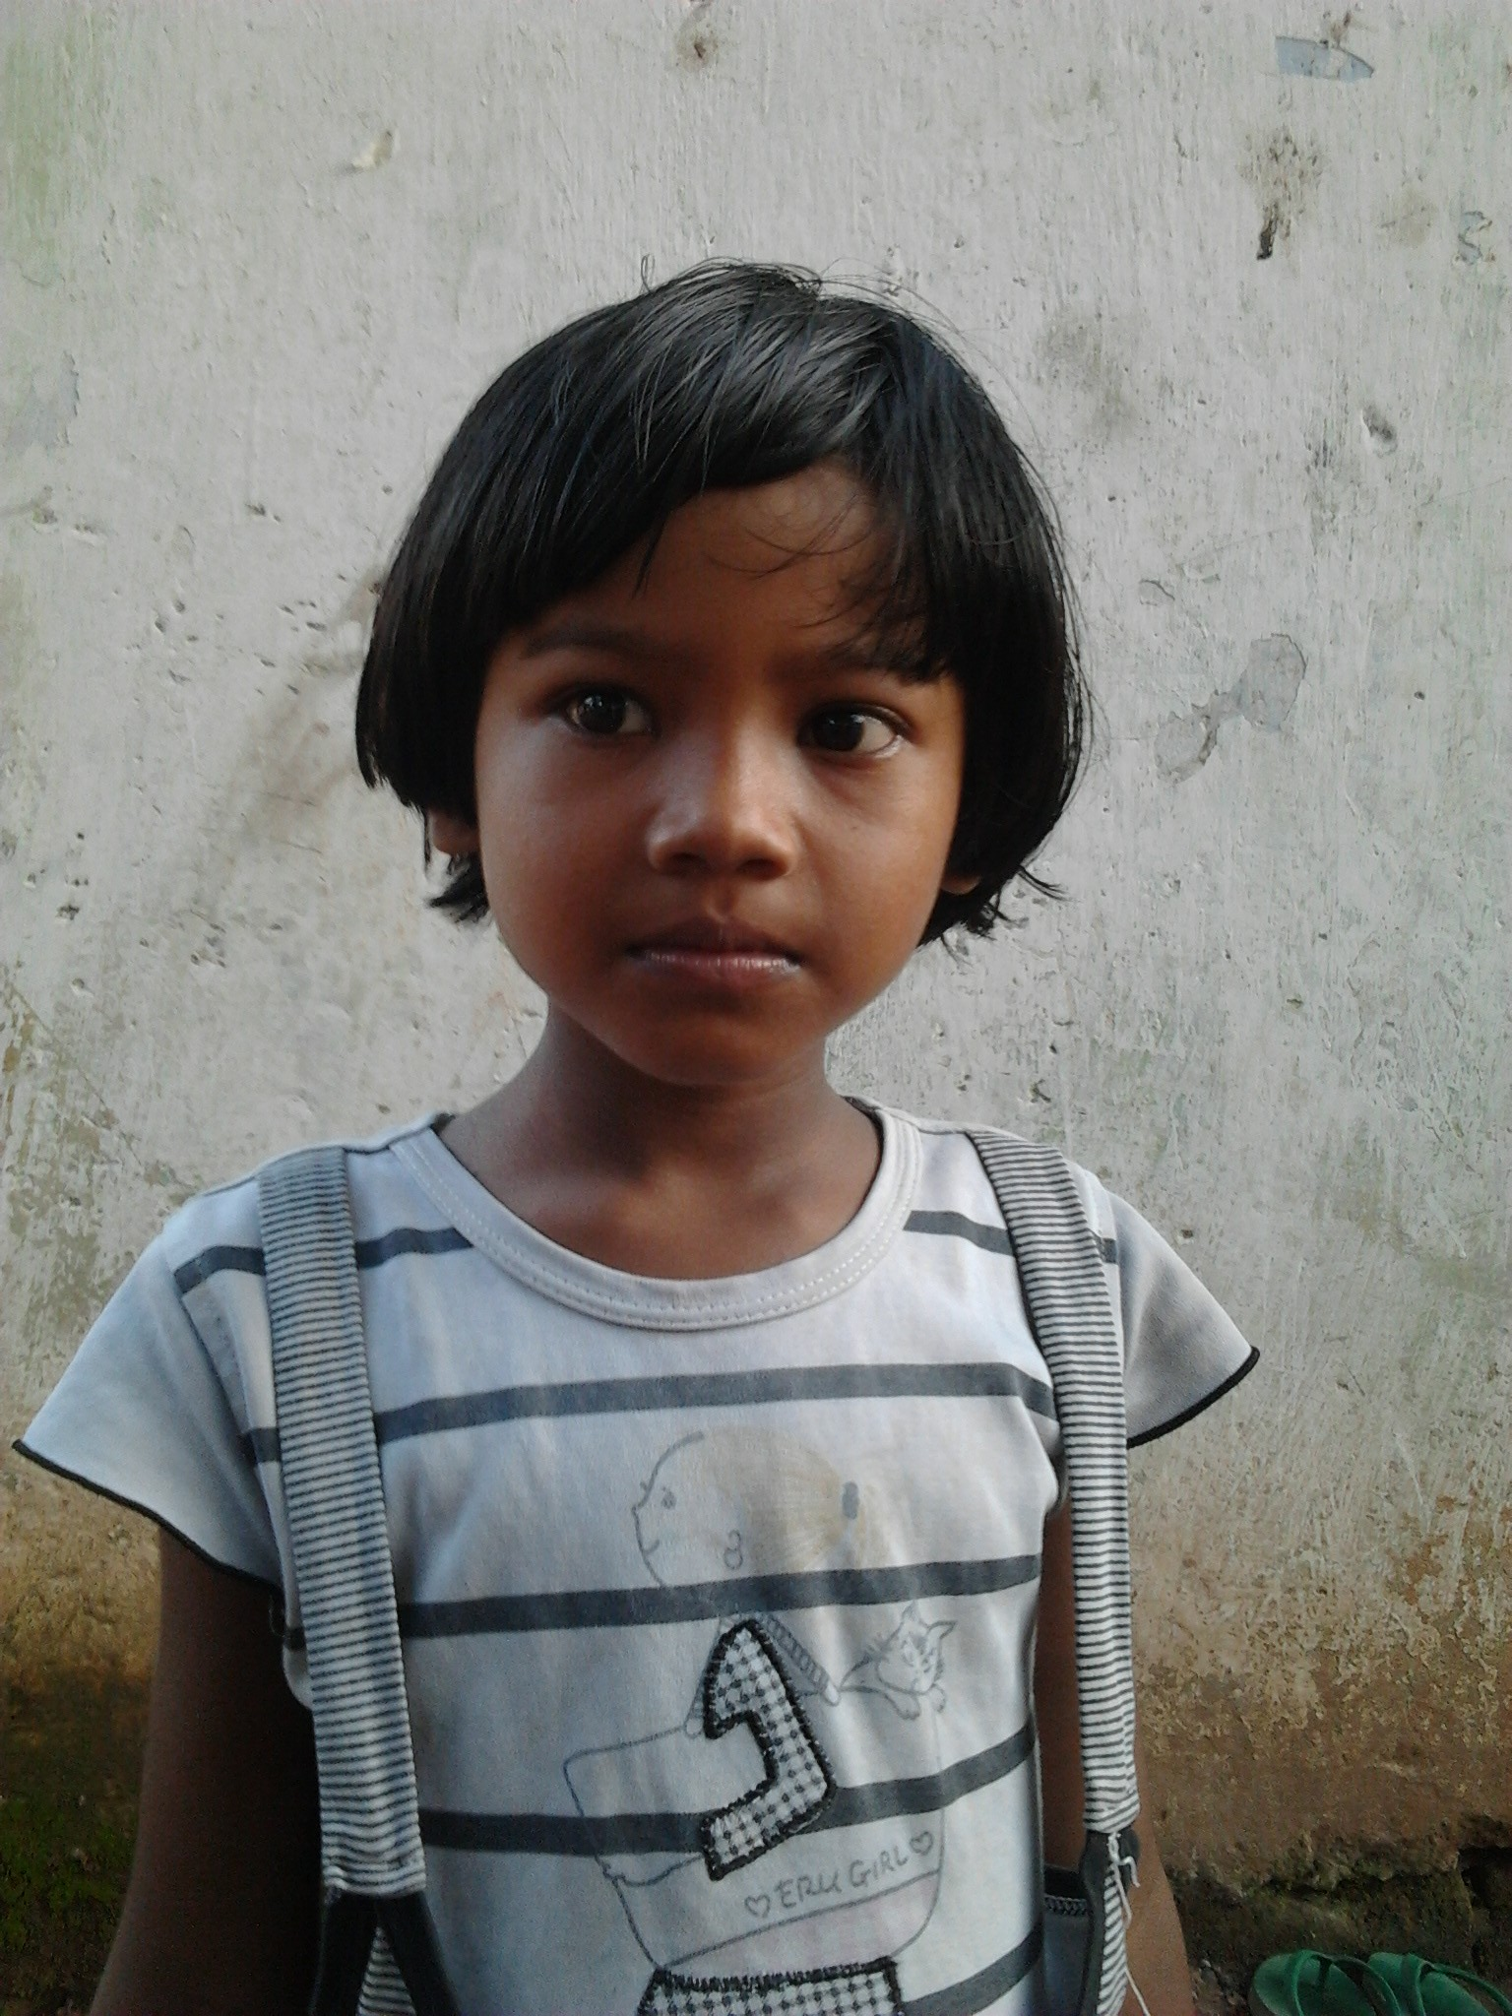

**PERSONAL DETAILS:**

* Class: II
* Gender: Female
* School: Srikrishna Public School, Bistupur, Jamshedpur
* Board of School: ICSE
* Medium of instruction: English

**DETAILS ABOUT FAMILY:**

* Father’s name: Debashish Patra
* Mother’s name: Jayanti Patra
* No of members in family: Four, one sister, mother and father
* Profession of father: Machine operator in a local company in Adityapur Industrial Area
* Profession of mother: Housewife

**FINANCIAL OVERVIEW:**

Annual income of household: Rs. 36000/-

**Total annual expenditure on education: Rs. 13,400/-**

Breakup of expenses

Tuition fees: Rs 350/- per month ( after 50% concession) = Rs. 4200/- (per year)

Admission fees: Rs. 1000/- (per year)

Stationery: Rs. 1000/- (per year)

Auto Fare: Rs. 600/- (per month)= Rs. 7200/- (per year)

**Average monthly expenditure on education: Rs. 1117/-**

**ENCLOSURES:**

1) Report card for the final exam of class I (previous class attended).

Report card – Page 1

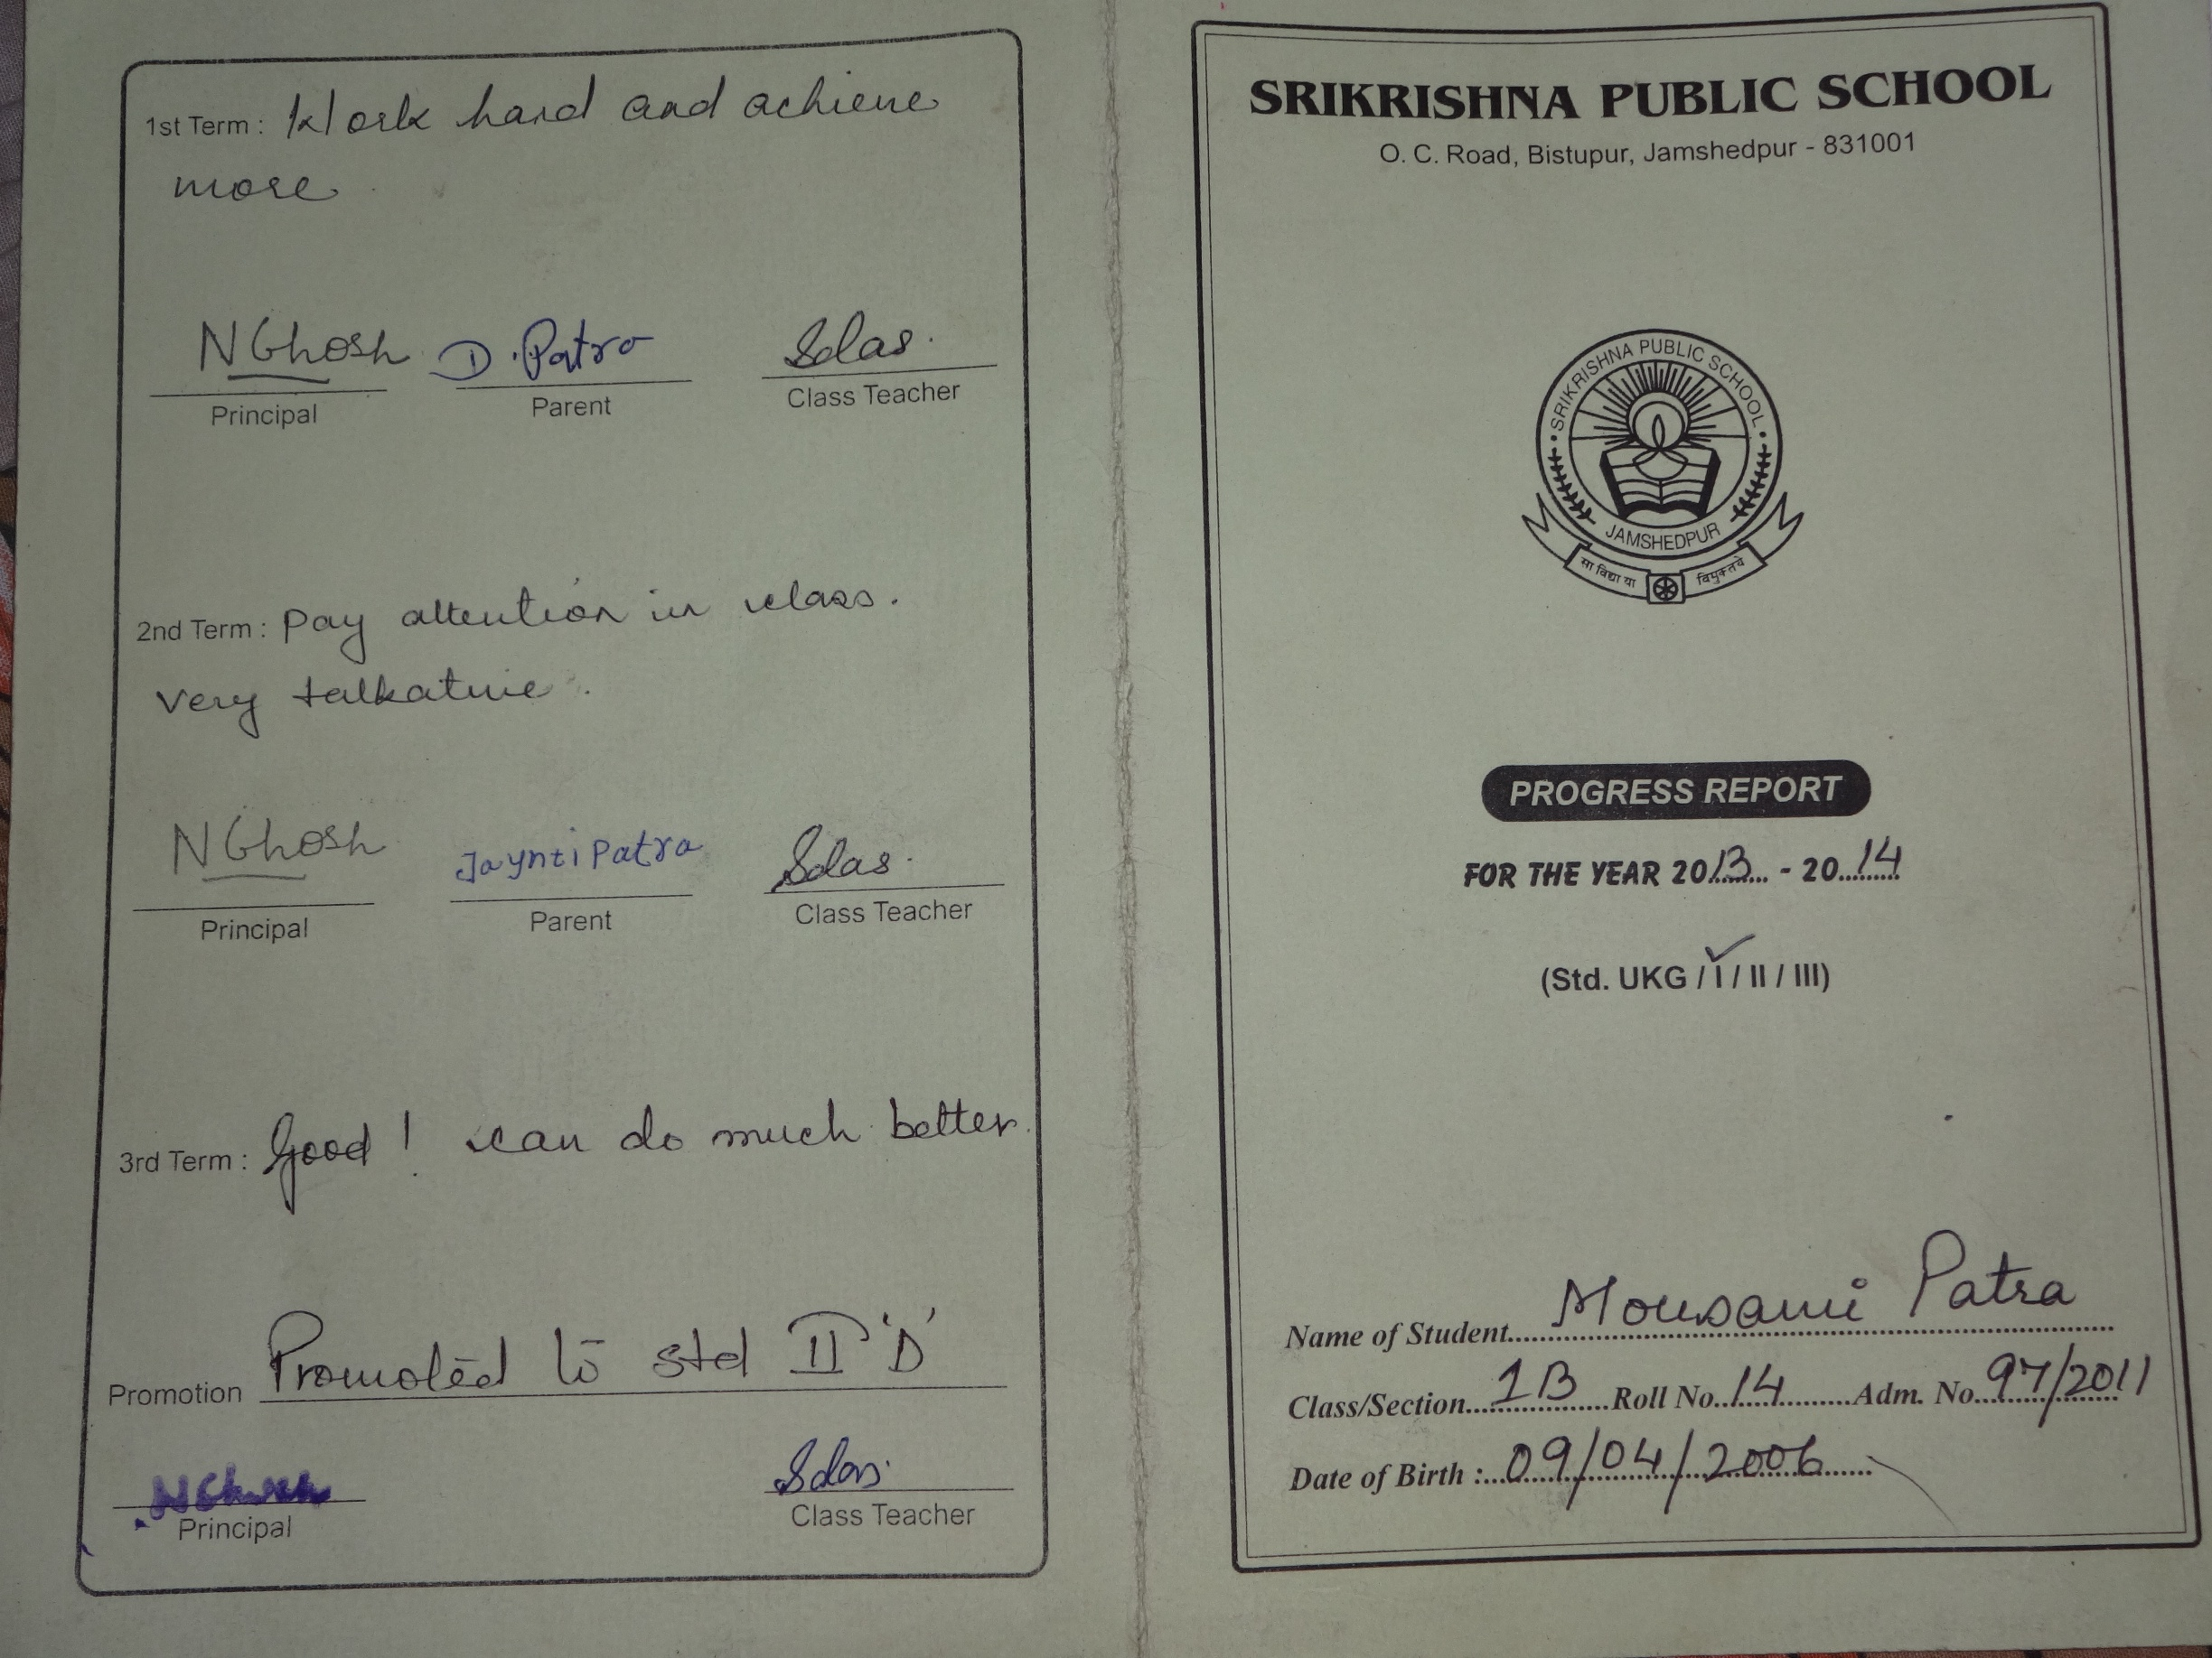

Report Card – Page 2

